Auto-Ticket Classification Using Flow Designer
Project Documentation
1. Introduction
- Project Title: Auto-Ticket Classification Using Flow Designer
- Team ID: SWTID-2026-9610
- Team Members: Harsheni S,Catherine Rebecca C,Pelleti Hima Sri,Prashanthini

2. Project Overview
- Purpose: The school IT helpdesk receives many support requests every day from students and teachers about network connectivity, hardware failures, account access and system performance. IT staff currently review every ticket by hand to identify the issue type, pick the Category and Subcategory, and inform the caller. This is slow, error-prone and does not scale. The goal of this project is to automate ticket classification in ServiceNow using Flow Designer so that tickets are categorised consistently without manual effort.
- Features:
  - Students enter only the Caller Name and Short Description; Category and Subcategory are not selected manually.
  - A Flow Designer flow triggers automatically when a new ticket is created.
  - The flow scans the Short Description for predefined keywords (WiFi, Projector, Password, Login, Slow, Hanging).
  - The matching Category and Subcategory are assigned automatically (see the mapping table below).
  - An email notification informs the caller that the ticket has been created.
  - The solution is completely no-code, easy to maintain and scalable.

Keyword in Short Description | Category | Subcategory
WiFi | Network | WiFi
Projector | Hardware | Projector
Password / Login | Access | Forgot Password
Slow / Hanging | Performance | Slow Computer
3. Architecture
- Frontend: The user interface is the standard ServiceNow Incident form (or ticket form) on the ServiceNow platform. The form is configured so that the caller only fills in Caller Name and Short Description. Category and Subcategory are filled in by the automation after submission.
- Backend: The business logic is built in Flow Designer. The flow uses the trigger “Created” on the ticket table, followed by conditional logic that checks whether the Short Description contains each keyword. A matching branch runs an “Update Record” action to set the Category and Subcategory, and a “Send Email” action notifies the caller.
- Database: Data is stored in the ServiceNow ticket (Incident) table. The key fields are Caller, Short Description, Category and Subcategory. The Category and Subcategory choice lists (Network/WiFi, Hardware/Projector, Access/Forgot Password, Performance/Slow Computer) are configured on the table. The flow reads Short Description and writes Category and Subcategory on the same record.
4. Setup Instructions
- Prerequisites:
  - A ServiceNow instance (for example a free Personal Developer Instance) with the admin role.
  - Flow Designer enabled on the instance (available by default).
  - Outbound email configured on the instance for notifications.
  - A web browser to access the instance.
- Installation:
- Create a ServiceNow developer account and request a Personal Developer Instance.
- Log in to the instance as an administrator.
- Configure the ticket form so that Caller and Short Description are the fields the student fills in.
- Add the Category and Subcategory choices listed in the mapping table.
- Open Flow Designer and create a new flow with the trigger “Created” on the ticket table.
- Add the keyword conditions, the Update Record actions and the Send Email action.
- Save, test and activate the flow.
5. Folder Structure
ServiceNow is a low-code platform and has no client/server folders, so the application is organised by component:
- Client: Ticket form layout (Caller, Short Description), Category and Subcategory choice lists, and the email notification template.
- Server: The Flow Designer flow – trigger (ticket created), keyword conditions, Update Record actions and Send Email action – along with the table and access control (ACL) configuration.
6. Running the Application
- Open the ticket form in ServiceNow and create a new ticket.
- Frontend: Enter the Caller Name and a Short Description such as “WiFi not working in Lab 2” and submit the ticket.
- Backend: The activated flow runs automatically; open Flow Designer > Executions to confirm the run, and open the ticket to see the Category and Subcategory filled in.
7. API Documentation
The project does not define custom endpoints. Tickets can also be created through the built-in ServiceNow Table API, and the same flow triggers on those records.
- Endpoint: POST /api/now/table/incident
- Parameters (JSON body): caller_id and short_description
- Example request:
{ "caller_id": "<caller sys_id>", "short_description": "Projector not working in Room 5" }
- Example response (after the flow runs):
{ "result": { "number": "INC0010001", "short_description": "Projector not working in Room 5", "category": "Hardware", "subcategory": "Projector" } }
8. Authentication
- Users sign in to ServiceNow with their user credentials (or the school’s single sign-on, if configured).
- Authorization is handled with roles and Access Control Rules (ACLs) on the ticket table, so only authorised users can read or modify ticket data.
- Students can create tickets; IT staff with the appropriate role can view and update them. API calls use the same authentication and ACLs.
9. User Interface
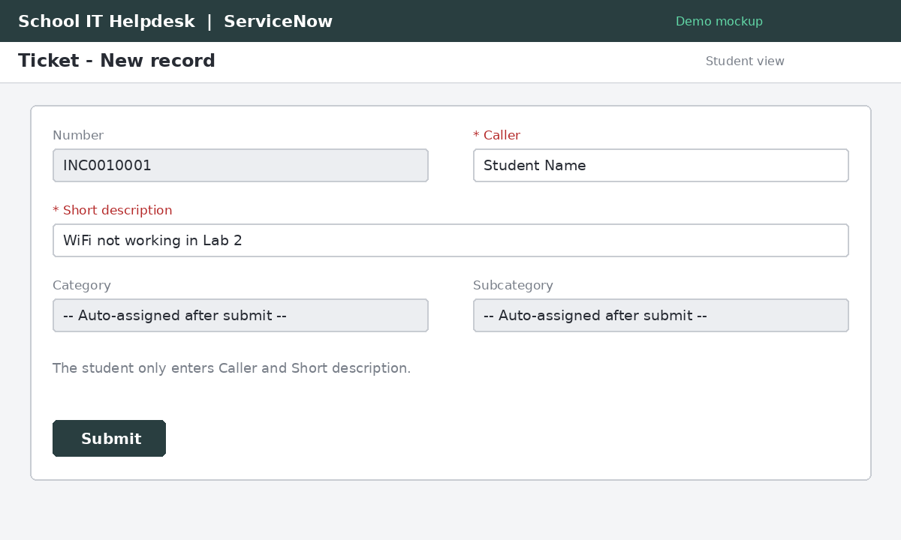
Figure 1: New ticket form - student enters only Caller and Short Description (demo mockup)
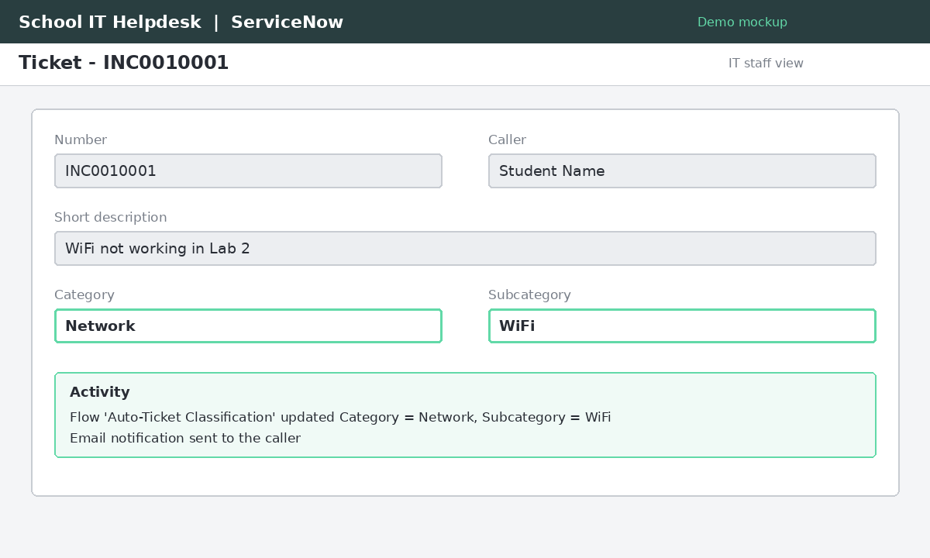
Figure 2: Ticket after submission with Category and Subcategory auto-assigned (demo mockup)
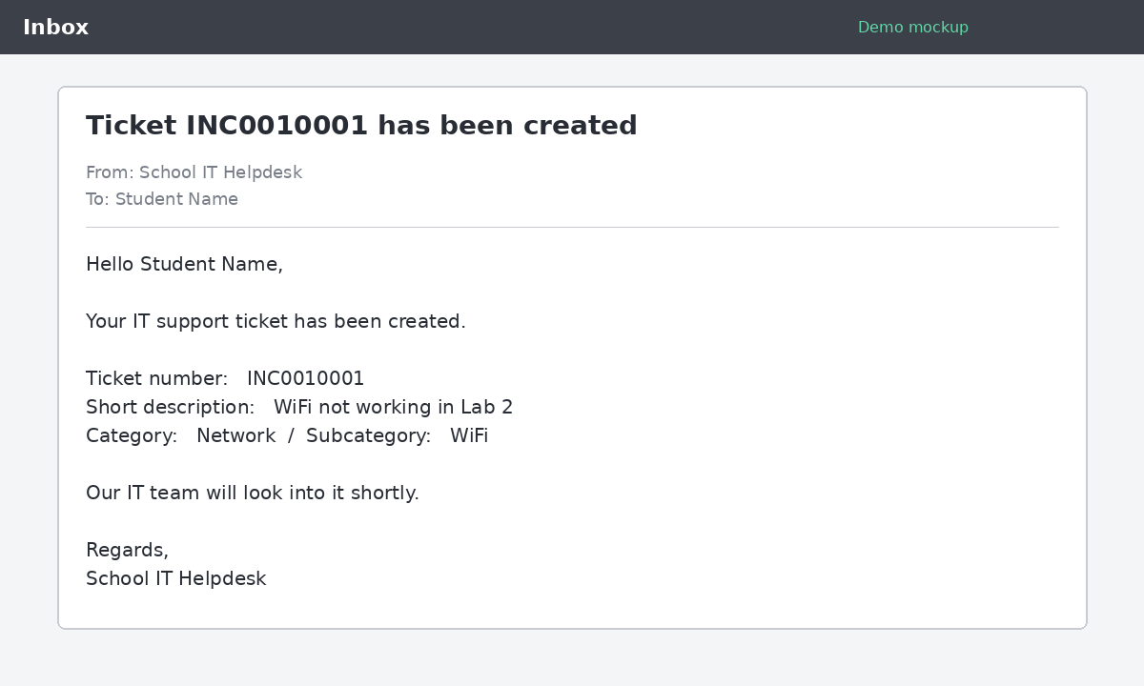
Figure 3: Email notification received by the caller (demo mockup)
10. Testing
- Testing is manual and functional, carried out in the ServiceNow instance. Each keyword scenario is tested end to end, data accuracy is checked, and access control is validated so that only authorised users can access or modify tickets.
- Tool used: Flow Designer Executions view to confirm each run.

Short Description (test input) | Expected Category | Expected Subcategory
WiFi not working in Lab 2 | Network | WiFi
Projector not turning on | Hardware | Projector
Forgot my password / cannot login | Access | Forgot Password
Computer is slow / hanging | Performance | Slow Computer

- Additional checks: the caller receives the email after ticket creation, and a user without the required role cannot modify ticket data.
11. Screenshots or Demo
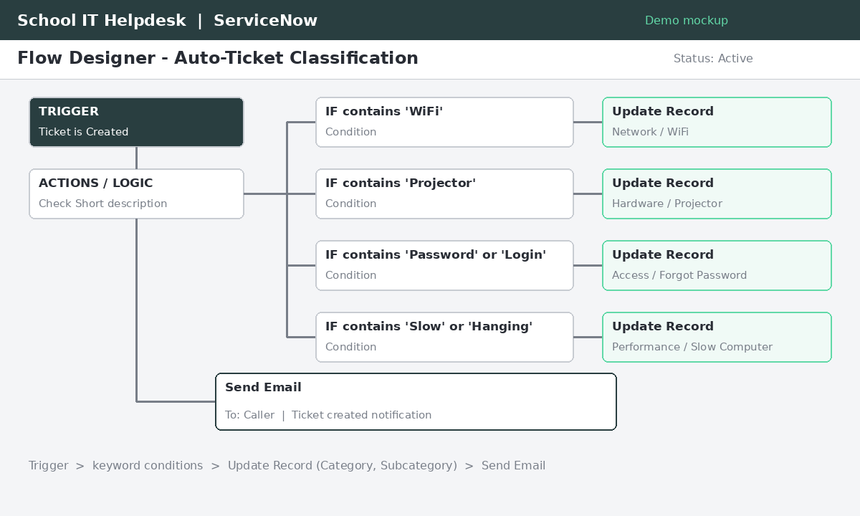
Figure 4: Flow Designer flow - trigger, keyword conditions, Update Record and Send Email (demo mockup)
Demo walkthrough: (1) submit a ticket with a keyword in the Short Description, (2) the flow runs automatically, (3) open the ticket to see the Category and Subcategory, (4) check the caller's email.
12. Known Issues
- Classification depends on the predefined keywords; a Short Description without any of them is not categorised automatically.
- Misspelled or differently worded keywords (for example “Wi-Fi”) may not be matched unless added to the flow.
- If a description contains keywords from more than one group, only one Category/Subcategory can be assigned.
13. Future Enhancements
- Add more keywords and categories as new issue types appear.
- Use machine-learning classification (for example ServiceNow Predictive Intelligence) instead of fixed keywords.
- Automatically assign the ticket to the right support group and set priority.
- Add a dashboard to track ticket volume by category.

